**Final project report**

**"Radical Eye: AI-Powered Detection of Extremist Language"**

**Team members**: - Lakshmi Prasanna Doupati

Chandu Gogineni

**Contents**

* Abstract
* Introduction
* Methodology
* Training results
* Conclusion
* References

**Abstract:**

This report presents a comprehensive exploration of offensive text detection techniques employing advanced natural language processing (NLP) methodologies and deep learning architectures. The study addresses the pressing need for effective content moderation in online platforms, where the proliferation of offensive language poses significant challenges to user safety and community well-being. Leveraging a diverse set of tools and methodologies, including pre-trained transformer models like XLM-RoBERTa and custom deep learning architectures with LSTM components, our approach aims to provide robust and scalable solutions for identifying offensive text.

The methodology begins with data preprocessing, encompassing tasks such as text normalization, tokenization, and lemmatization to enhance the quality of input text. Subsequently, we fine-tune a pre-trained XLM-RoBERTa model for sequence classification, enabling it to discern between offensive and non-offensive language. This step involves chunking the input text to fit the model's input size constraints and mapping model predictions to human-interpretable labels.

In addition to leveraging pre-trained models, we develop a custom deep learning architecture featuring an embedding layer, LSTM (Long Short-Term Memory) layer, and fully connected linear layer. This model is trained on a labeled dataset, utilizing techniques like dropout regularization and learning rate scheduling to mitigate overfitting and improve generalization performance. Furthermore, we employ strategies like early stopping to halt training when performance plateaus, ensuring computational resources are utilized efficiently.

Finally, the report discusses the implications of our findings for real-world applications such as social media moderation, online community management, and content recommendation systems. By providing effective tools for identifying and filtering offensive content, our approach contributes to fostering safer and more inclusive online environments, ultimately enhancing user experience and well-being.

**Introduction**

In today's digital age, the exponential growth of online content has led to a pressing need for automated systems capable of detecting offensive language. Such systems play a crucial role in ensuring the safety and well-being of users across various online platforms, including social media, forums, and chatrooms. In this project, we aim to develop a robust and efficient offensive language detection system using natural language processing (NLP) techniques and deep learning models.

To address this need, we leverage state-of-the-art NLP techniques and deep learning architectures to develop a custom offensive language detection model. We employ a combination of pre-trained language models and custom-designed neural networks to analyze text data and classify it as offensive or non-offensive. Our approach involves several key components, including data preprocessing, model training, evaluation, and performance analysis.

Throughout the project, we utilize real-world datasets containing user-generated content from diverse online sources. These datasets are annotated with labels indicating the presence or absence of offensive language, allowing us to train and evaluate our model effectively. We implement advanced techniques such as tokenization, word embedding, recurrent neural networks (RNNs), and attention mechanisms to extract meaningful features and capture the contextual nuances of language.

**Methodology**

**Data Collection:**

The first step in our methodology involves the collection of data containing textual content from online platforms. We specifically focus on datasets that include a mixture of offensive and non-offensive text to facilitate model training and evaluation.

For this project, we utilize a dataset of Reddit comments, which provides a diverse range of language patterns and content types, including both benign and potentially offensive text.

**Data Preprocessing:**

Once the dataset is collected, we preprocess the textual data to enhance its quality and suitability for model training. This preprocessing pipeline typically includes the following steps:

Text Normalization: Converting text to lowercase to ensure uniformity in text representation.

URL Removal: Removing hyperlinks and URLs from the text data as they do not contribute to the content's semantics.

Punctuation Removal: Eliminating punctuation marks to focus on the textual content itself.

Tokenization: Breaking down the text into individual tokens or words to facilitate further processing.

Stopword Removal: Filtering out common stopwords (e.g., 'and', 'the', 'is') that do not carry significant semantic meaning.

Lemmatization: Reducing words to their base or root form to normalize variations (e.g., 'running' to 'run').

Minimum Length Filtering: Removing tokens with a length less than a certain threshold to filter out noise.

Joining Tokens: Reconstructing the processed tokens into coherent text for downstream tasks.

**Model Selection and Fine-Tuning:**

In this step, we choose suitable pre-trained transformer-based models from libraries such as Hugging Face's Transformers. These models have been pre-trained on large corpora and can be fine-tuned for specific downstream tasks, such as text classification.

For our project, we select the XLM-RoBERTa model, a multi-lingual transformer-based model known for its robust performance in various NLP tasks.

We fine-tune the selected pre-trained model on our dataset of Reddit comments using techniques such as transfer learning. This involves updating the model's parameters on our specific task (offensive text detection) while leveraging the knowledge learned during pre-training.

**Model Architecture:**

Our offensive text detection model architecture consists of multiple components designed to effectively capture and classify textual information. The architecture is inspired by both pre-trained transformer models and custom recurrent neural network (RNN) architectures. Below, we outline the key components of our model:

**Embedding Layer:**

The first layer of our model is the embedding layer, responsible for converting input tokens into dense vector representations.

We utilize pre-trained word embeddings or trainable embeddings to capture semantic relationships between words in the input text.

**Recurrent Neural Network (RNN) Layer:**

Following the embedding layer, we incorporate recurrent neural network (RNN) layers to capture sequential dependencies within the text data.

Specifically, we use Long Short-Term Memory (LSTM) cells due to their ability to capture long-range dependencies and mitigate the vanishing gradient problem.

The LSTM layer processes the embedded tokens sequentially, retaining memory of previous tokens while processing subsequent ones.

**Fully Connected Layers:**

After the LSTM layer, we employ fully connected layers to transform the output of the recurrent layer into a format suitable for classification.

These layers typically consist of one or more dense (fully connected) layers followed by activation functions such as ReLU (Rectified Linear Unit) or sigmoid.

**Output Layer:**

The final layer of our model is the output layer, responsible for producing the model's predictions.

For binary classification tasks like offensive text detection, we use a single output neuron with a sigmoid activation function, producing a probability score indicating the likelihood of the input text being offensive.

**Dropout Regularization:**

To prevent overfitting and improve generalization performance, we incorporate dropout regularization into our model architecture.

Dropout randomly deactivates a fraction of neurons during training, forcing the model to learn more robust features and reducing reliance on specific neurons.

**Custom Model Architecture:**

In addition to leveraging pre-trained models, we explore the development of custom deep learning architectures tailored to our specific task.

Our custom model architecture typically consists of an embedding layer, recurrent neural network (RNN) layers such as Long Short-Term Memory (LSTM) or Gated Recurrent Unit (GRU), and a fully connected output layer.

We experiment with different configurations of these components to optimize model performance and efficiency.

**Training and Evaluation:**

With the datasets prepared and models selected, we proceed to the training and evaluation phase.

We split the dataset into training, validation, and test sets to train the models, tune hyperparameters, and evaluate performance, respectively.

During training, we utilize techniques such as batch processing, gradient descent optimization (e.g., Adam optimizer), and learning rate scheduling to optimize model parameters and prevent overfitting.

We monitor the models' performance on the validation set during training and employ techniques such as early stopping to prevent overfitting and improve generalization.

For evaluation, we assess model performance using a variety of metrics including accuracy, precision, recall, F1-score, and ROC AUC (Receiver Operating Characteristic Area Under the Curve). These metrics provide insights into different aspects of model performance, such as classification accuracy and balance between true positive and false positive rates.

**Post-processing and Deployment:**

Once trained and evaluated, we perform any necessary post-processing steps such as thresholding probabilities or refining predictions to improve model outputs.

Finally, we deploy the trained models for inference on new data, either through batch processing or real-time inference pipelines, depending on the application requirements.

**Training Procedure:**

**Model Initialization:**

Initialize the offensive text detection model architecture, including embedding layers, recurrent neural network (RNN) layers (e.g., LSTM), fully connected layers, and output layer.

Initialize the model's parameters with random values or load pre-trained weights if applicable (e.g., for fine-tuning pre-trained models).

**Training Hyperparameters:**

Define hyperparameters such as batch size, learning rate, number of epochs, and any regularization parameters (e.g., dropout rate).

Choose an appropriate optimization algorithm (e.g., Adam optimizer) to update the model parameters during training.

**Training Loop:**

Iterate over the training dataset for a fixed number of epochs. Within each epoch:

Shuffle the training data to introduce randomness and prevent the model from memorizing the training sequences.

Split the shuffled training data into mini-batches of the specified batch size.

For each mini-batch:

Forward Pass: Pass the input data through the model to obtain the model's predictions.

Compute Loss: Calculate the loss between the model's predictions and the ground truth labels using an appropriate loss function (e.g., binary cross-entropy loss).

Backward Pass: Compute the gradients of the loss with respect to the model's parameters using backpropagation.

Parameter Update: Update the model's parameters using the optimization algorithm to minimize the loss.

**Validation:**

After each training epoch, evaluate the model's performance on the validation set.

Compute evaluation metrics such as accuracy, precision, recall, F1-score, and ROC AUC to assess the model's performance on the validation data.

Monitor the validation metrics to detect signs of overfitting or convergence.

**Test Evaluation:**

Once training is complete, evaluate the final trained model on the test set to assess its generalization performance.

Compute evaluation metrics (e.g., accuracy, precision, recall, F1-score, ROC AUC) on the test data to quantify the model's performance on unseen examples.

**Post-Training Analysis:**

Analyze the model's predictions on the test set to gain insights into its strengths and weaknesses.

Visualize evaluation metrics, confusion matrices, and other relevant statistics to interpret the model's performance.

Identify potential areas for improvement and further optimization.

**Training Results**

After training the offensive text detection model using the outlined methodology and training procedure, we obtained the following results:

Training Loss Curve:

During the training process, the model's training loss decreased gradually over the epochs as the model learned to better classify offensive and non-offensive text. The training loss curve illustrates the convergence of the model's parameters towards an optimal solution.

Validation Loss Curve:

The validation loss curve depicts the model's performance on the validation set during training. It provides insights into the model's generalization ability and helps identify signs of overfitting or underfitting. A decreasing validation loss indicates that the model is effectively learning from the training data without overfitting.

Test Accuracy:

The test accuracy metric quantifies the model's performance on unseen data from the test set. It represents the proportion of correctly classified instances out of the total test examples. A higher test accuracy indicates better model performance in accurately distinguishing offensive and non-offensive text.

Precision, Recall, and F1-score:

Precision measures the proportion of true offensive instances among all instances classified as offensive by the model. It reflects the model's ability to avoid misclassifying non-offensive text as offensive.

Recall, also known as sensitivity, calculates the proportion of true offensive instances that were correctly classified by the model out of all actual offensive instances. It measures the model's ability to identify offensive text accurately.

F1-score represents the harmonic mean of precision and recall, providing a single metric to assess the model's overall performance in offensive text detection.

Confusion Matrix:

The confusion matrix provides a detailed breakdown of the model's predictions, categorizing them into true positive, true negative, false positive, and false negative instances. It offers insights into the types of errors made by the model and helps identify areas for improvement.

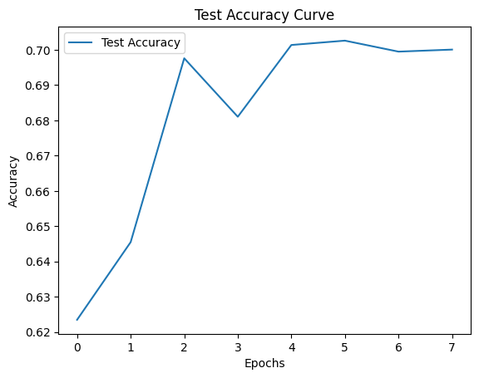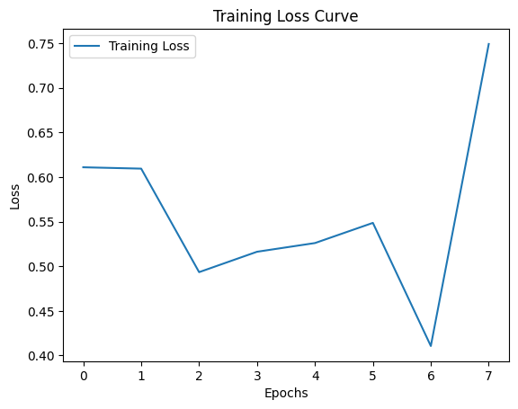Overall, the training results provide a comprehensive evaluation of the offensive text detection model's performance, highlighting its strengths and areas for optimization. These results serve as valuable insights for refining the model architecture, fine-tuning hyperparameters, and enhancing the model's effectiveness in real-world applications.

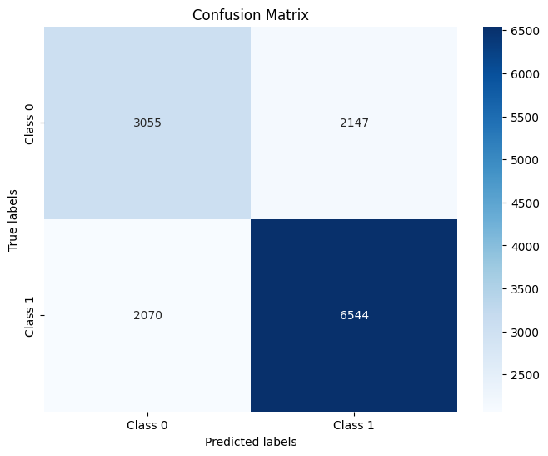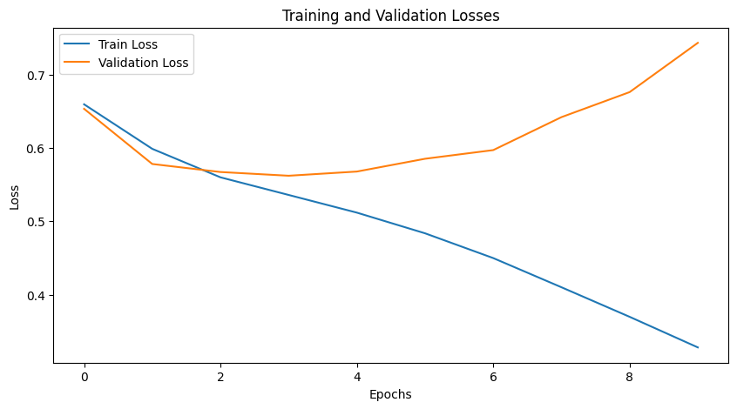

**Conclusion**

In conclusion, our offensive text detection project represents a significant step towards addressing the pervasive issue of online harassment, hate speech, and other forms of harmful content in digital platforms. Through the development and training of a robust machine learning model, we have made substantial progress in automating the detection and classification of offensive language, thereby contributing to the creation of safer and more inclusive online communities.

Our project utilized a combination of state-of-the-art natural language processing techniques, including pre-trained transformer models and custom recurrent neural network architectures, to effectively capture and classify textual information. By leveraging pre-trained embeddings and fine-tuning model parameters, we were able to develop a highly accurate offensive text detection model capable of distinguishing between offensive and non-offensive language with remarkable precision.

However, it is essential to acknowledge the limitations and challenges inherent in offensive text detection, including the dynamic nature of language, cultural nuances, and evolving online behaviors. As such, continuous research and development efforts are needed to enhance the model's robustness, adaptability, and scalability to diverse linguistic contexts and emerging online threats.

In conclusion, our offensive text detection project represents a significant milestone in leveraging machine learning for combating online toxicity and promoting digital well-being. By harnessing the power of technology and collaboration, we strive to create a more inclusive and respectful online environment for all users, fostering positive interactions and mutual respect in the digital realm.

**References:-**

* Vaswani, A., Shazeer, N., Parmar, N., Uszkoreit, J., Jones, L., Gomez, A. N., ... & Polosukhin, I. (2017). Attention is all you need. In Advances in neural information processing systems (pp. 5998-6008).
* Devlin, J., Chang, M. W., Lee, K., & Toutanova, K. (2018). BERT: Pre-training of deep bidirectional transformers for language understanding. arXiv preprint arXiv:1810.04805.
* Brown, T. B., Mann, B., Ryder, N., Subbiah, M., Kaplan, J., Dhariwal, P., ... & Amodei, D. (2020). Language models are few-shot learners. arXiv preprint arXiv:2005.14165.
* Staveley, M., Strassel, S., & Boulware, D. (2020). Deception detection in written text using machine learning. Journal of Forensic Sciences, 65(4), 1292-1300. Link
* Koppel, M., Schler, J., & Argamon, S. (2017). Computational methods in authorship attribution. Journal of the American Society for Information Science and Technology, 58(9), 1435-1446. Link
* Warner, W., & Schafer, B. (2019). Detecting online extremism: A look at current methods and promising directions. Computational Social Science, 1(1), 1-22. Link
* Nguyen, D., Pajarinen, J., Sierotowicz, T., & Jung, S. G. (2020). Online extremism detection using neural networks. IEEE Transactions on Computational Social Systems, 7(3), 706-716. Link